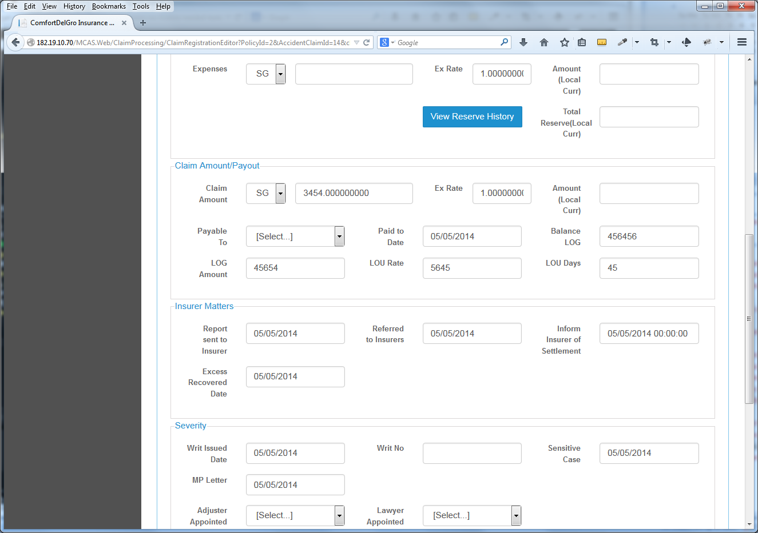

**1) View Reserve History** – To Change this to View Reserve & Payment History. This should show the Three Different Columns – Reserve, Expense & Payment as highlighted in Mr. Yip’s Documentation. This is not the same function as the View Reserve History under the Reserve Tab.

**2) Payable To** – Currently this is a dropdown menu to a list of companies. Should change this to a Free Text Box. **Enhancement:** Allow User to create/insert Multiple Claim Amount/Payouts for new parties.